
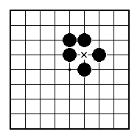
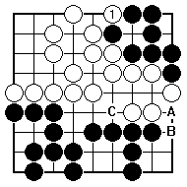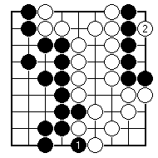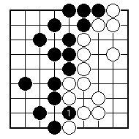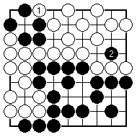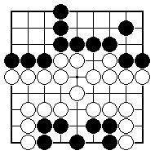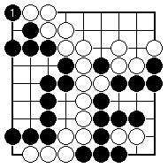
White played 1, taking a stone. Should Black play A, B or C?

Black took at 1; then White played at 2. Where does Black play now?

White took at 1; then Black played at 2. Where does White play now?

Where should White play to start a ko, and why?

Black just captured at 1. Find a ko threat for White.

Black just captured at 1. Find a ko threat for White.

NAME:
BRITISH GO ASSOCIATION CERTIFICATE LEVEL 3 - SHEET 10

KO FIGHTS

